**NAGARJUNA COLLEGE OF ENGINEERING AND TECHNOLOGY**

(An Autonomous College under VTU, Belagavi, Accredited by NAAC with “A+ ” Grade)



**NSS Activity**

Submitted in partial fulfillment for the award of the degree in

**BACHELOR OF ENGINEERING**

**IN**

**CSE(Data Science)**

**Submitted by**

|  |  |
| --- | --- |
| **T PAVAN KUMAR** | **1NC22CD051** |

**Under the Mentorship of**

**Mrs. Sushma B S**

Assistant Professor

Department of CSE(Data Science)

Nagarjuna College of Engineering and Technology

Bengaluru-562 164

**DEPARTMENT OF CSE(Data Science)**

**NAGARJUNA COLLEGE OF ENGINEERING AND TECHNOLOGY**

**(An Autonomous College under VTU, Accredited by** **NAAC with “A+ ” Grade)**

**Mudugurki (V), Venkatagirikote (P), Devanahalli (T), Bengaluru-562164.**

**2023-24**

**NAGARJUNA COLLEGE OF ENGINEERING AND TECHNOLOGY**

**(An Autonomous College under VTU, Accredited by NAAC with “A+ ” Grade**)

**Bengaluru-562164, Karnataka, India**

**DEPARTMENT OF CSE(Data Science)**



**CERTIFICATE**

This is to Certified that T PAVAN KUMAR 1NC22CD051, bonafide student of Nagarjuna College of Engineering and Technology, an autonomous College under Visveswaraya Technological University, Belagavi carried out in NSS activity for partial fulfillment the award of Bachelor of Engineering in CSE(Data Science) during the academic year 2023-24.

It is certified that all corrections/suggestions indicated for assessment have been incorporated in the report deposited in the departmental library. The Activity points have been approved, as it satisfies the academic requirement in respect for the prescribed format.

|  |  |
| --- | --- |
| **Name & Signature of the Mentor**  **Mrs. Sushma B S**  Assistant Professor  Department of CSE(Data Science)  NCET | **NSS Programme Officer/SAGY Coordinator**  **Prof. Sanath Kumar K R**  NSS PO  NCET, Bengaluru |
| **Name & Signature of the HOD**  **Dr. Syed Naimatullah Hussain**  Professor and Head  Department of CSE(Data Science)  NCET | **Name & Signature of the Principal**  **Dr. B V Ravishankar**  Principal, NCET |

**ACKNOWLEDGEMENT**

The satisfaction and euphoria that accompany the successful completion of any task would be incomplete without the mention of people who made it possible, whose consistent guidance and encouragement crowned our effort with success. I consider it is our privilege and duty to express our gratitude and respect to all those who guide us in the completion of this project.

First and foremost, it's our immense pleasure to thank our beloved Mentor **Mrs. Sushma B S**, Assistant Professor, Department of CSE(Data Science), Nagarjuna College of Engineering and Technology, for helping, guiding and strengthening us to complete this NSS Activity.

I would like to express our sincere thanks to **Dr. Syed Naimatullah Hussain**, Professor and Head Department of CSE(Data Science). Nagarjuna College of Engineering and Technology for her valuable suggestions and guidance throughout the period of this NSS Activity.

We would like to convey my heartiest regard and thanks to NSS PO, **Prof. Sanath Kumar K R**, Department of Civil engineering, for his valuable suggestion and constant encouragement that he provided at every moment we needed it during this activity.

I take this privilege to express our deep gratitude to **Dr. B V Ravi Shankar** Principal, Nagarjuna College of Engineering and Technology for his constant support and encouragement in preparation of this report and for providing library and laboratory facilities needed to prepare this NSS Activity .

I would like to thank My Beloved Parents for their Support and Encouragement throughout my career.

Last but not least, I would like to thank our friends, teaching and non-teaching staff of NCET.

**T PAVAN KUMAR**

**1NC22CD051**

**DECLARATION**

I hereby declare that the project report entitled submitted by me to Nagarjuna College of Engineering and Technology in partial fulfillment of the requirement for the award of the degree of Bachelor of Engineering in CSE(Data Science) a record of bonafide report of NSS activity carried out by me under the Mentoring of Mrs. Sushma B S. I further declare that the work reported here has not been submitted either in part or full, for the award of any other degree in this institute or any other institute or university.

**T PAVAN KUMAR**

**1NC22CD051**

**Report On Plastic-Free Campus Campaign**

**Date:** 14 May 2024

**Introduction:**

On 14 May 2024, as part of our NSS class, we conducted an activity to make our campus plastic-free. Our goal was to collect plastic waste, create awareness about the harmful effects of single-use plastics, and encourage shops on campus to stop using them.

**Objectives:**

* To collect and properly dispose of plastic waste on campus.
* To raise awareness about the negative impact of single-use plastics.
* To encourage shops on campus to stop using single-use plastics.

**Activities Conducted:**

**Collection of Plastic Waste:**

* We started the day by gathering in front of the main building. Our team was divided into smaller groups, and each group was assigned a specific area of the campus to clean.
* We collected all types of plastic waste, including bottles, bags, wrappers, and other items. We made sure to wear gloves and use trash bags to collect the waste safely.
* After collecting, we brought all the plastic waste to a designated dumping area on campus. The collected plastic waste was then sorted and prepared for proper disposal and recycling.

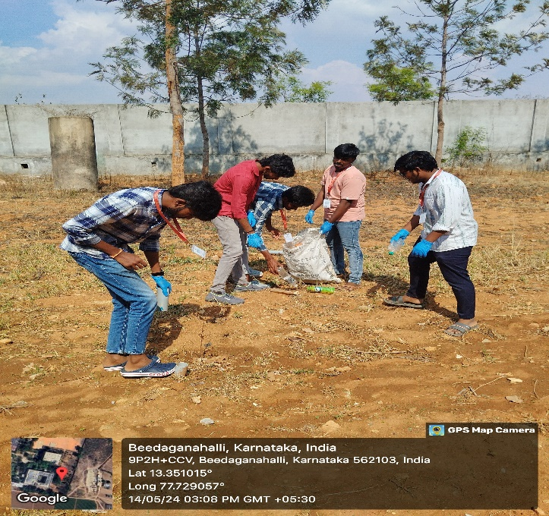

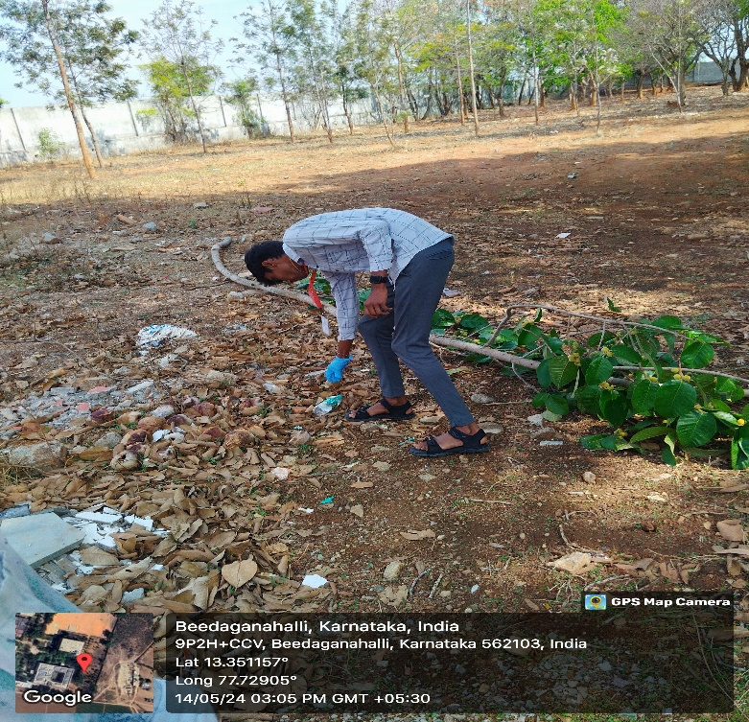

Fig 1

Fig 2

**Awareness Campaign:**

After the collection activity, we focused on raising awareness about the dangers of single-use plastics. We visited various shops and canteens on campus to talk to the shop owners and staff.

We explained the harmful effects of plastic on the environment, such as pollution, harm to wildlife, and the long time it takes for plastic to decompose.

We handed out pamphlets with information on why it is important to reduce plastic use and provided tips on alternative materials, like cloth bags, paper bags, and reusable containers.

**Discussions with Shop Owners:**

We had discussions with the shop owners and staff, encouraging them to stop using single-use plastics. We suggested they switch to more eco-friendly options.

Some shop owners were concerned about the cost and availability of alternatives. We assured them that switching to eco-friendly options is beneficial in the long run and that customers are increasingly supportive of environmentally friendly practices.

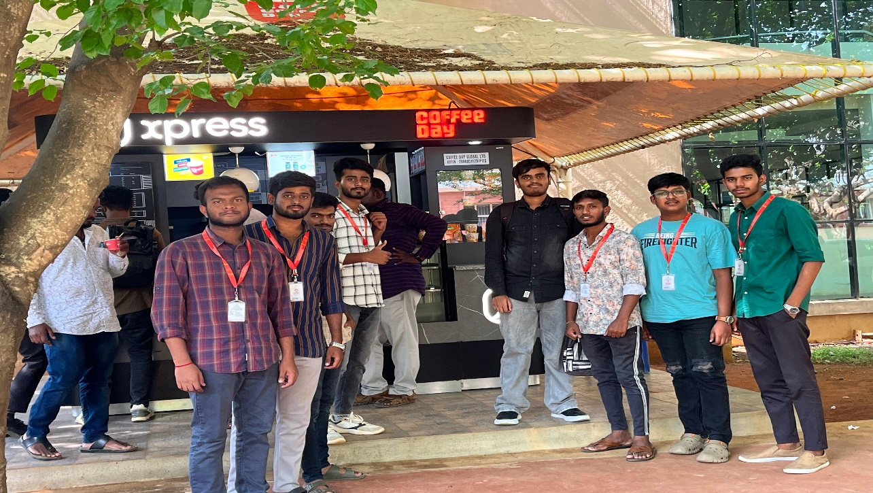

Fig 3

**Outcomes of the Activity:**

* We collected a significant amount of plastic waste, making the campus cleaner and more pleasant.
* The awareness campaign was well-received by the shop owners and staff. Many of them showed interest in reducing plastic use and switching to eco-friendly alternatives.
* The activity helped us understand the importance of working together to achieve a common goal and the impact of small actions on the environment.

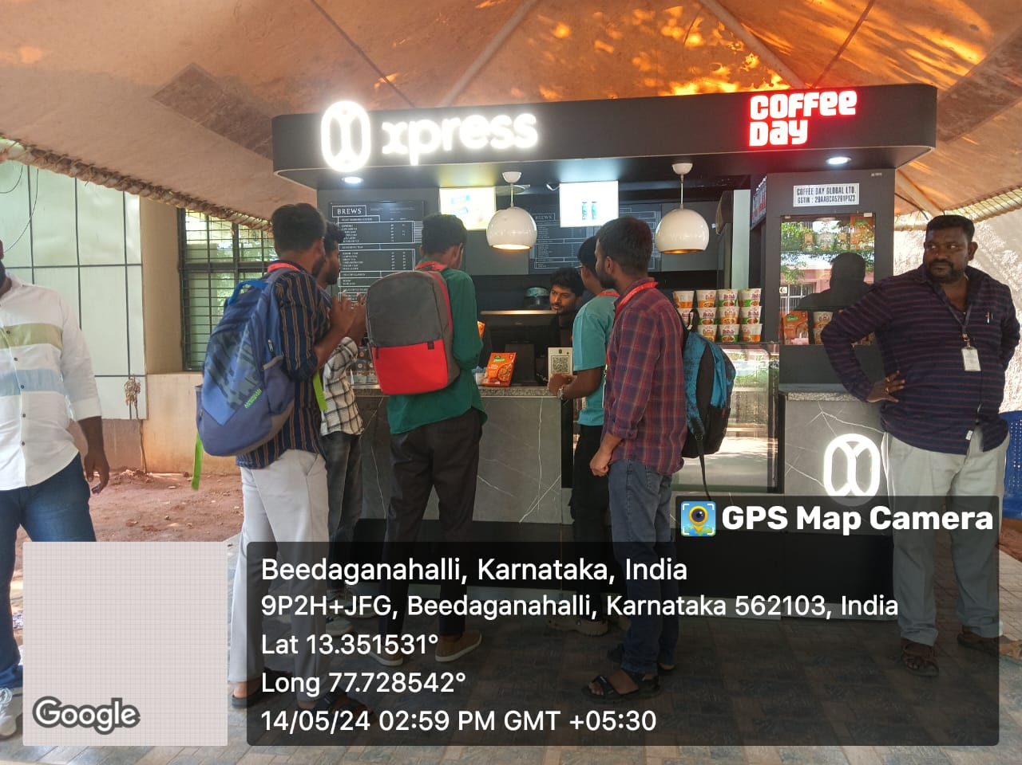

Fig 4

**Conclusion:**

The Plastic-Free Campus campaign was a successful NSS activity. It not only helped clean our campus but also raised awareness about the harmful effects of single-use plastics. By encouraging shop owners to reduce plastic use, we took a step towards making our campus more eco-friendly. This activity showed us that even small efforts can make a big difference in protecting our environment.

**Report on Ayushman Bharat Awareness Program at Beedaganahalli Village**

**Date of Visit**: 7 June 2024

**Introduction:**

As part of our NSS class, we visited Beedaganahalli village to spread awareness about the Ayushman Bharat scheme. This was our NSS activity for the week. Our goal was to inform the villagers about this health scheme and how they can benefit from it.

**Objectives:**

* To teach the villagers about the Ayushman Bharat scheme.
* To explain the benefits and coverage provided by the scheme.
* To show the villagers how to register and use the services.
* To answer any questions they had about the scheme.

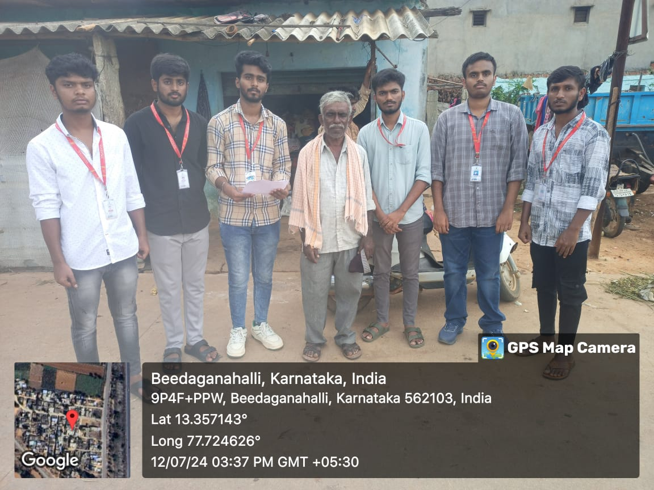

Fig 1

**Activities Conducted:**

**Introduction Session:**

We started by explaining why we were there. The villagers gathered in the community hall, and we made sure everyone was comfortable and listening.

**Talking about Ayushman Bharat:**

We explained about the Ayushman Bharat scheme. We talked about:

* Ayushman Bharat is a health insurance scheme for low-income families.
* Each family gets health coverage up to Rs. 5 lakh per year.
* The scheme covers many medical expenses, like hospital stays, surgeries, and treatments for serious illnesses.

**Showing How to Register:**

We showed the villagers how to register for the scheme using a smartphone and told them about the nearest centers where they could register.

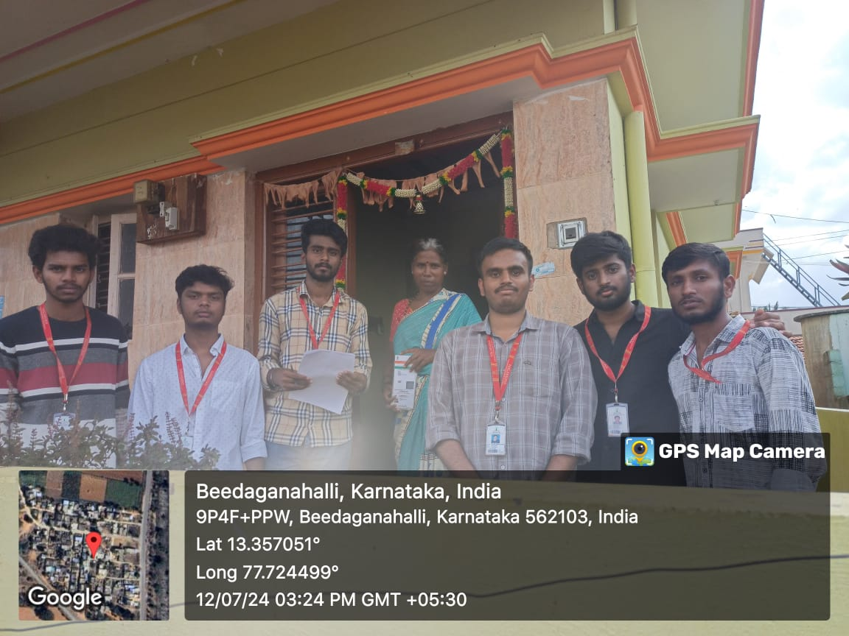

Fig 2

**Outcomes of the Visit:**

Fig 3

* The villagers now understand the Ayushman Bharat scheme and its benefits.
* Many villagers showed interest in registering for the scheme right away.
* The session helped clear up confusion and made the villagers feel more confident about using government healthcare services.

**Conclusion:**

The visit to Beedaganahalli village was a successful NSS activity. It taught the villagers about the Ayushman Bharat scheme and encouraged them to take steps to ensure their health and well-being. We believe that such awareness programs are important for the success of government schemes and for helping rural communities.

**Follow-Up Report on Visit for Ayushman Bharat Awareness**

**at Beedaganahalli Village**

**Date:** 25-06-2024

**Introduction:**

For our third-week NSS activity, we revisited Beedaganahalli village to continue our Ayushman Bharat awareness campaign. Our main goal this time was to check if the villagers had enrolled in the scheme and to help those who hadn't. We also aimed to provide additional assistance by downloading copies of the Ayushman Bharat cards.

**Objectives:**

* To follow up on the Ayushman Bharat awareness program.
* To check the enrolment status of the villagers using their Aadhaar cards.
* To help villagers download and obtain their Ayushman Bharat cards.
* 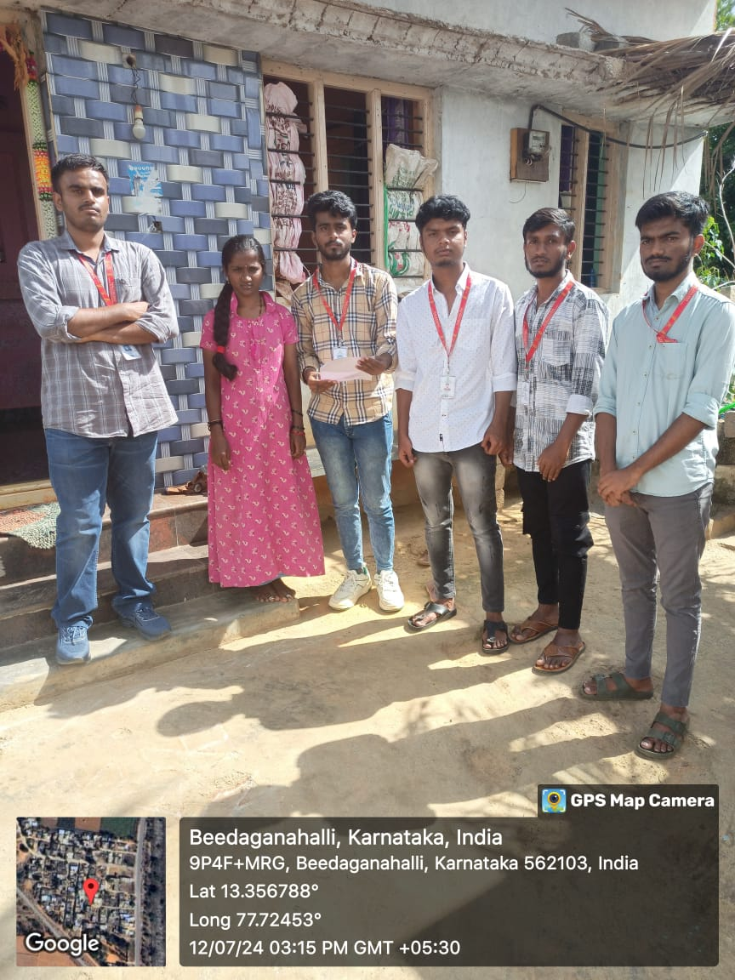To provide further information and assistance as needed.

Fig 1

**Activities Conducted:**

**Checking Enrolment Status:**

* Using the collected Aadhaar details, we checked the Ayushman Bharat website to see if the villagers were already enrolled in the scheme.
* For those who were enrolled, we downloaded a copy of their Ayushman Bharat card. For those who were not enrolled, we guided how to complete the enrolment process.

**Downloading Cards:**

We provided them a soft copy of the Ayushman Bharat cards for those who were enrolled.

**Providing Additional Assistance:**

* We answered any questions the villagers had about the scheme, enrolment process, and benefits.

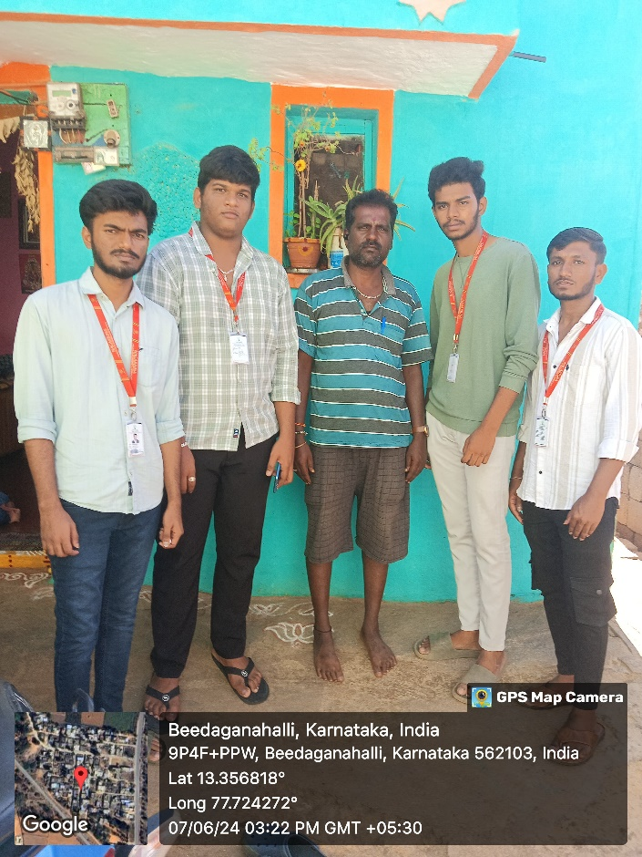We also reminded them about the importance of the Ayushman Bharat scheme and how it can help them access better healthcare.

Fig 2

**Outcomes of the Visit:**

* We successfully collected Aadhaar details from a number of villagers.
* Many villagers who were already enrolled received a copy of their Ayushman Bharat card.
* Villagers who were not yet enrolled received guidance on how to enroll and the benefits of doing so.
* The visit reinforced the importance of the Ayushman Bharat scheme and provided practical assistance to the villagers.

**Conclusion:**

The follow-up visit to Beedaganahalli village was a productive NSS activity. It helped ensure that more villagers were aware of and enrolled in the Ayushman Bharat scheme. By providing copies of the Ayushman Bharat cards and additional guidance, we made it easier for the villagers to access healthcare services. This activity highlighted the importance of continuity in community service projects and the positive impact of follow-up visits.

**NSS Activity Report: Survey On Government Schemes Utilized**

**By Beedaganahalli Villagers**

**Date:** 12-07-2024

**Venue:** Beedaganahalli Village

**Objectives:**

* To educate the residents of Beedaganahalli village about various government schemes available to them.
* To increase awareness and ensure that the benefits of these schemes reach the intended recipients.
* To collect data on the government schemes applied for by the villagers.
* To understand the challenges faced by villagers in accessing these government schemes.
* To provide support and clarify doubts regarding the application process for these schemes.

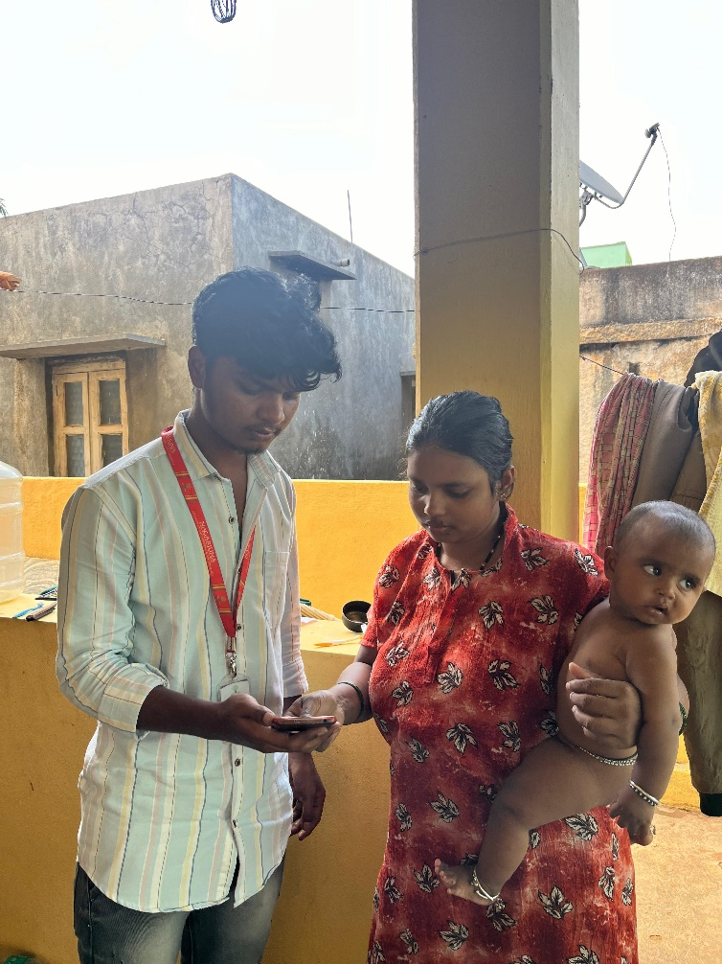

Fig 1

**Activities Conducted:**

**Awareness Campaign:**

* We began our day with an awareness campaign. Our team divided into small groups and visited different parts of the village.
* We used simple language to explain the details of various government schemes, such as the Pradhan Mantri Awas Yojana, Jan Dhan Yojana, Gruhalakshmi, Ayushman Bharat and other government schemes.

**Data Collection**:

* After the awareness sessions, we started collecting data on the government schemes applied for by the villagers. Each group was assigned specific households to visit.
* We recorded details such as the name of the head of the family, the schemes they had applied for, the status of their applications, and any issues they faced during the application process.
* This information was collected using a simple questionnaire designed to capture the necessary details efficiently.



**Outcomes:**

* We successfully conducted the awareness campaign and reached out to a significant number of families in Beedaganahalli village.
* The data collected provided valuable insights into the reach and effectiveness of government schemes in the village.
* Villagers expressed gratitude for the information and support provided, and many showed interest in applying for schemes they were previously unaware of.

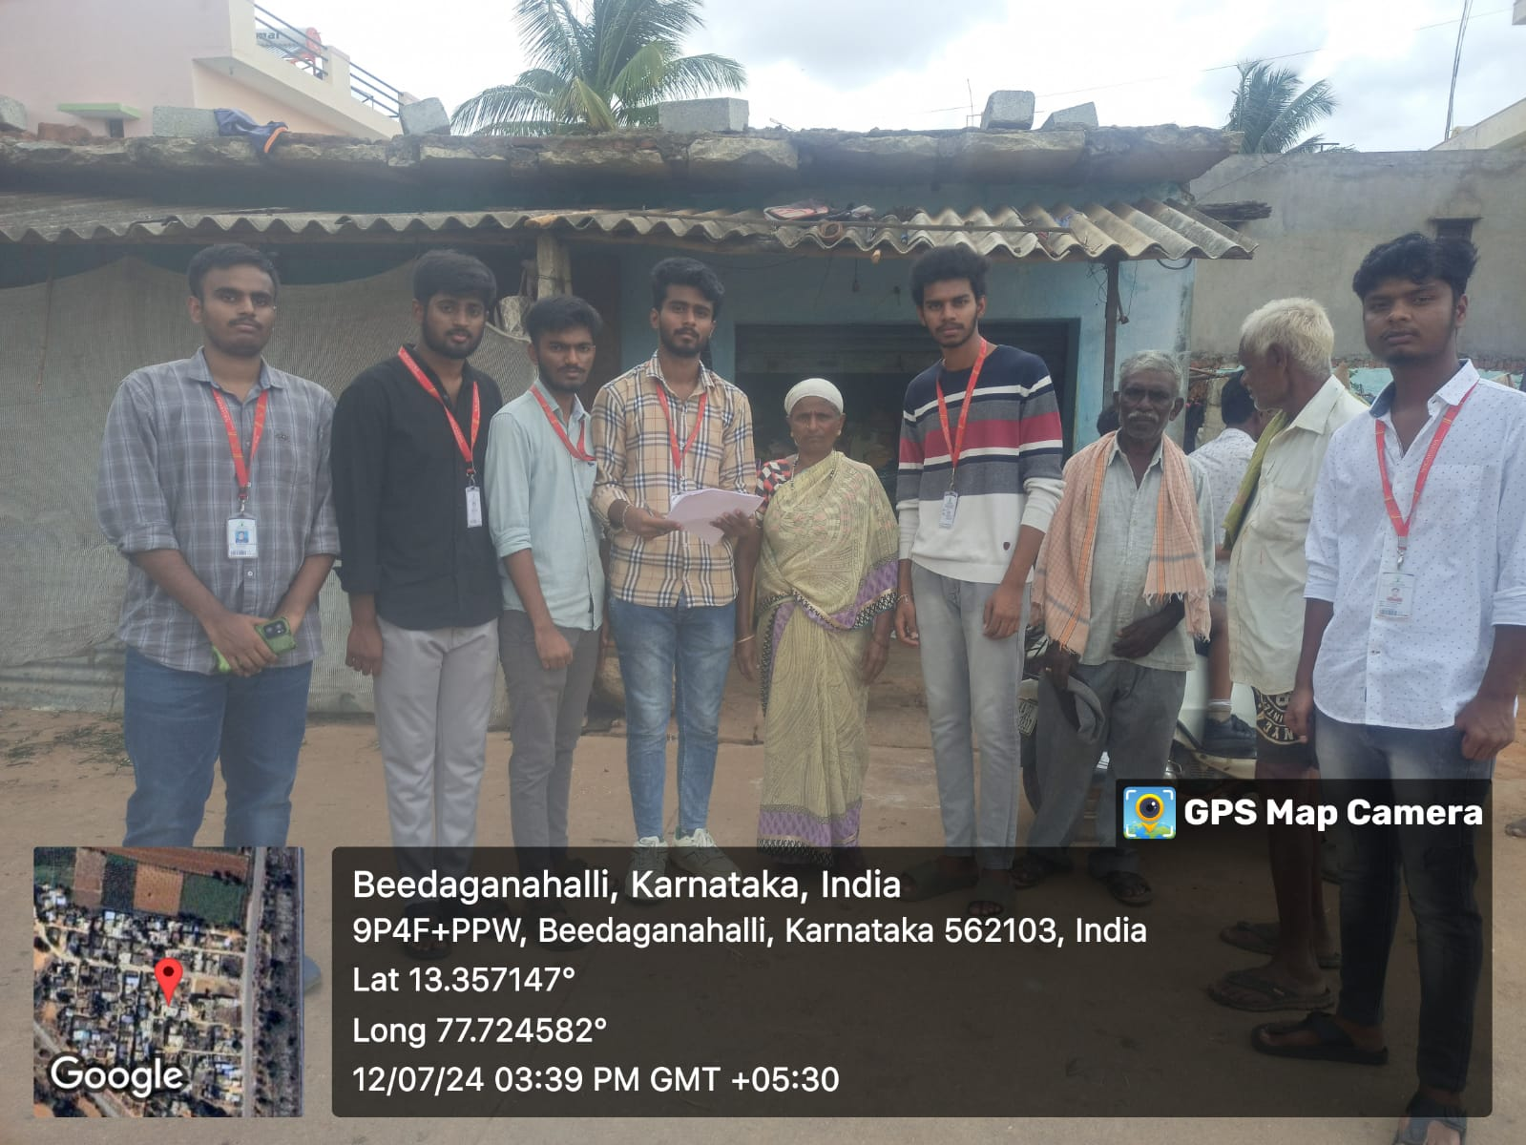

**Conclusion:**

The NSS activity at Beedaganahalli village was a meaningful and impactful experience. It not only helped in spreading awareness about government schemes but also brought to light the challenges faced by villagers in accessing these benefits. Continued efforts and regular follow-up activities will be essential to ensure that the objectives of the awareness campaign are fully realized.

**References :**

1. [PMJAY - Beneficiary Portal (nha.gov.in)](https://beneficiary.nha.gov.in/)
2. <https://static.pib.gov.in>
3. <https://www.mygov.in>